**Solutions Jquery: 1st to 14th page and CUSTOM JQUERY SLIDER – ID Number: 1008843**

<!DOCTYPE html>

<html xmlns="http://www.w3.org/1999/xhtml">

<head>

<title></title>

<script src="https://ajax.googleapis.com/ajax/libs/jquery/1.12.0/jquery.min.js"></script>

<script type="text/javascript">

$(function () {

$("#btnApply1").click(function(){changePara1();});

$("#btnApply2").click(function(){changePara2();});

$("#btnApplyChild").click(function(){changeChildStyle();});

//alert("here");

//changePara1(); // $('#mypara').css("background-color" , "yellow").css("border" , "1px solid red");

//});

//$("#btnApply2").click(function () { changePara2() });

//$(btnApplyChild).click(function () { changeChildStyle() });

});

function changePara1() {

// basic jquery syntax $(selector).action()

// you can chain many actions

// no quotes around mypara, or use "#mypara"

$("#mypara").css("border", "1px solid red").css("background-color", "yellow");

// both backgroundColor and background-color are acceptable

// in above css call

}

function changePara2() {

// you can pass a json string with multiple name value

// pairs. No quotes around { }

$(mypara).css({"border":"1px solid yellow","background-Color":"green", "color":"yellow"});

}

function changeChildStyle() {

// div>p[id=#imp] will not work, also div cannot be inside a p

// div p[id=imp] will also work

// p:nth-child(1) selects all paras that are first level

// children of a tag (indexing starts at 1)

// div>p:nth-child(1) all paras that are first child of div

$("div>p:nth-child(1)").css({ "border": "1px solid yellow", "background-Color": "green", "color": "yellow" });

}

</script>

</head>

<body>

<div>

jquery is ver popular Javascript library

<p id="imp">

jquery selectors are the best part of jquery

</p>

<p>

Sometimes the selectors are tricky i.e., when to use # and when not to

</p>

</div>

<p id="mypara"> Apply jquery style to it </p>

<input type="button" value="Change Para Style 1" name="btnApply1" id="btnApply1" />

<input type="button" value="Change Para Style 2" name="btnApply2" id="btnApply2" />

<input type="button" value="Change Child Style" name="btnApplyChild" id="btnApplyChild" />

</body>

</html>

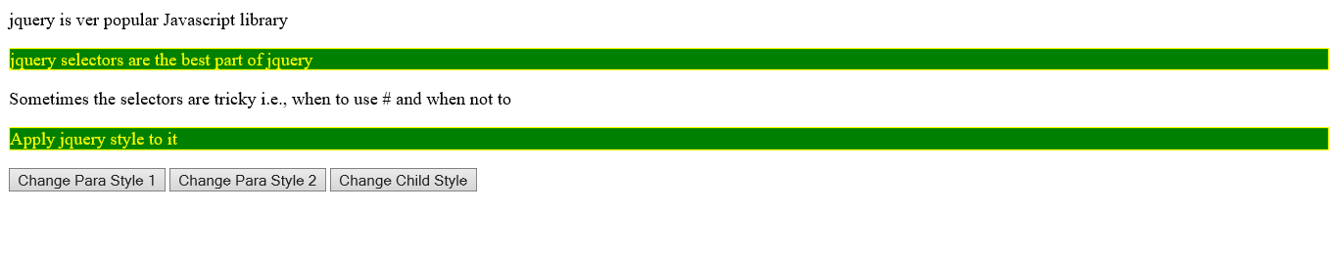

<!DOCTYPE html>

<html xmlns="http://www.w3.org/1999/xhtml">

<head>

<title> Test of JQuery </title>

<script src="https://ajax.googleapis.com/ajax/libs/jquery/1.12.0/jquery.min.js"></script>

<script type="text/javascript">

$(document).ready(function () { // like body onload

$("body").css({ 'background-color': 'rgb(255,255,180)', 'color': 'green' });

$("input[name='btnTest']").click(function () {

$("p.mainHeading").hide();

//$(mypara).css("background-color","red");}); // one paragraph

$("p").css("background-color", "red"); // all paragraphs

$("#rnews").removeClass('blueYellowStyle');

$("#rnews").addClass('redYellowStyle');

});

$("input[name='btnTest2']").click(function () {

$("#rnews").removeClass('redYellowStyle');

$("#rnews").addClass('blueYellowStyle');

});

$(mypara).mouseover(function () { $(this).css("background-color", 'rgb(200,200,255)'); });

$(mypara).mouseout(function () { $(this).css("background-color", "white"); });

$("li").mouseover(function () { //$("li").mouseover(function () {

$(this).removeClass('blueYellowStyle').removeClass('mainHeading');

$(this).addClass('redYellowStyle');

});

$("li").mouseout(function () { // $("li.first").mouseout(function () {

$(this).removeClass('redYellowStyle');

$(this).addClass('blueYellowStyle').addClass('mainHeading');

});

});

</script>

<style type="text/css">

.mainHeading {

font-size: 14pt;

color: blue;

background-color: yellow;

}

.redYellowStyle {

color: red;

background-color: white;

}

.blueYellowStyle {

color: blue;

background-color: yellow;

}

.greenYellowStyle {

color: green;

background-color: yellow;

}

</style>

</head>

<body>

<p class="mainHeading"> This is a test of jquery </p>

<p id="mypara"> Apply jquery style to it </p>

<p id="mypara2"> This is second paragraph </p>

<ul>

<li class='first'> First Item in the List

<li class='second'> Second Item in the List

<li class='Third'> Third Item in the List

</ul>

<div id="rnews">Recent News for XYZ Corporation </div>

<input type="button" value="Test" name="btnTest" />

<input type="button" value="Test2" name="btnTest2" />

</body>

</html>

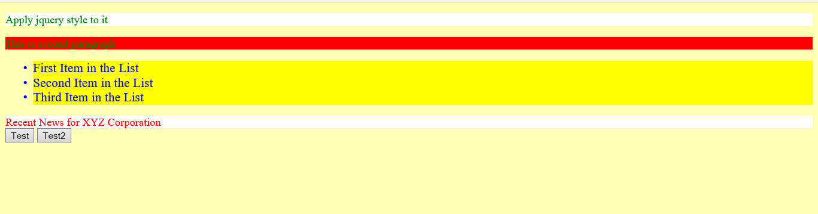

<!DOCTYPE html>

<html xmlns="http://www.w3.org/1999/xhtml">

<head>

<title> Test of JQuery </title>

<style type="text/css">

body {

font: 10pt;

font-family: Arial;

}

.mainHeading {

font-size: 14pt;

color: blue;

background-color: yellow;

}

</style>

<script src="https://ajax.googleapis.com/ajax/libs/jquery/1.12.0/jquery.min.js"></script>

<script type="text/javascript">

$(document).ready(function () { // like body onload

$("body").css({ 'backgroundColor': '#ffffa0', 'color': '#f00000' });

$("#testm").mousemove(function (e) {

var out1 = e.clientX + ":" + e.clientY;

$("#mp").css({ 'left': e.clientX, 'top': e.clientY, 'width': 100, 'height': 20 });

$("#mp").html(out1);

}); //pageX, pageY for page coordinates

// $("#testm").click(function (e) { alert(e.clientX + ":" + e.clientY) }); // both mousemove and click do not work together on div

});

</script>

</head>

<body>

<p class="mainHeading"> This is a test of jquery </p>

<div id="mp" style="position:absolute;border:1px solid blue;"></div>

<div id="testm" style="width:300px;height:200px;border:1px solid red;">test area for mouse move </div>

<input type="button" value="Test" name="btnTest" id="btnTest" />

</body>

</html>

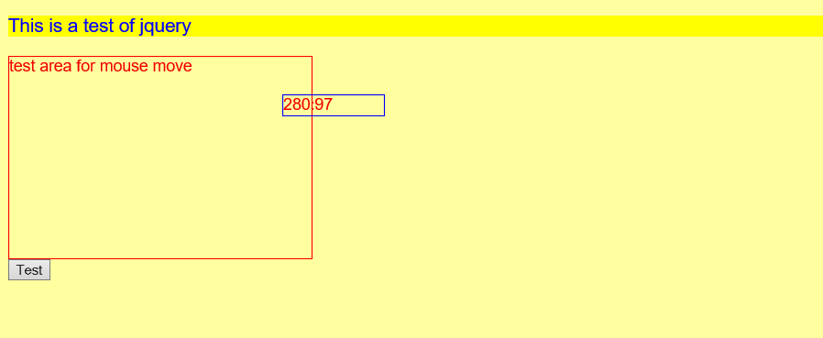

<!DOCTYPE html>

<html xmlns="http://www.w3.org/1999/xhtml">

<head>

<title> Test of JQuery </title>

<script src="https://ajax.googleapis.com/ajax/libs/jquery/1.12.0/jquery.min.js"></script>

<script type="text/javascript">

function changePara() {

$("div#mypara>#subpara").css("border", "1px solid red").css("backgroundColor", "yellow");

// select id=subpara inside a div with id=mypara

// space can be used in jQuery instead of a / in XPath

// can also use $("div#mypara p#subpara")

// $("div#mypara p") will select all p inside mypara

// $("div#mypara p[id=subpara]")

}

function changePara2() {

$('html>body>div>p[id=subpara]').css("border", "1px solid red").css("backgroundColor", "yellow");

//$('div>p[id=subpara]') // means any level

//$('div>p[id*="sub"]') //* means anywhere in id

// $('div>p[id^="sub"]') //^ means starts with

//$('div>p[id$="bpara"]')// $ means ends with

}

function searchPara() {

var ptext = $('div>p[id="subpara"]').text();

// .text() action returns the text content of an element

var psel = $('div>p[id="subpara"]')

if (ptext.indexOf("inside") >= 0)

psel.css("border", "1px solid red").css("backgroundColor", "yellow");

}

</script>

</head>

<body>

<p> jquery selection via XPath </p>

<div id="mypara">

jQuery uses XPath like syntax to select an element.

<p id="subpara">a paragraph inside a div</p>

</div>

<input type="button" value="Change Para Style (selection)" onclick="changePara()" name="btnApply" />

<input type="button" value="Change Para Style 2 (selection)" onclick="changePara2()" name="btnApply2" />

<input type="button" value="Search Para" onclick="searchPara()" name="btnApply" />

</body>

</html>

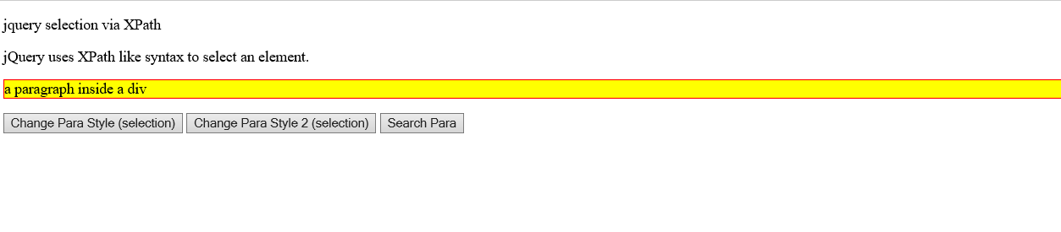

<!DOCTYPE html>

<html xmlns="http://www.w3.org/1999/xhtml">

<!--JQEx5.html-->

<head>

<title></title>

<style type="text/css">

.info {

border:1px solid red;

font-size:18pt;

color:green;

}

</style>

<script src="https://ajax.googleapis.com/ajax/libs/jquery/1.12.0/jquery.min.js"></script>

<script type="text/javascript">

$(function () {

$("#btnFadeOut").click(function () {

$("div#test").add("p").html("test of fading in JQuery").fadeOut(10000).addClass("info");

//$("div#test p").remove(); not working

});

});

</script>

</head>

<body>

<input type="button" name="btnFadeOut" id="btnFadeOut" value="Fade Out"/>

<div id="test">

</div>

</body>

</html>

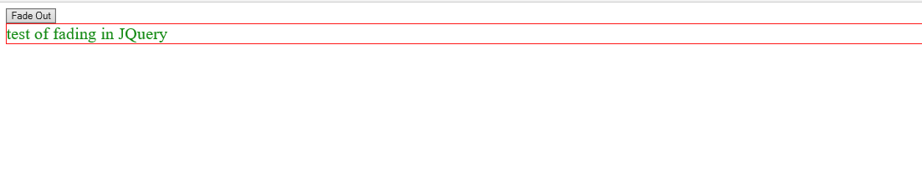

<!DOCTYPE html>

<html xmlns="http://www.w3.org/1999/xhtml">

<!-- AdderJQ.htm -->

<head>

<title> Web Adder </title>

<script src="https://ajax.googleapis.com/ajax/libs/jquery/1.12.0/jquery.min.js"></script>

<script type="text/javascript">

$(function () {

$('#btnAdd').css({ 'background-color': 'red' });

//$('input[name="btnAdd"]').css({'background-color':'red'});

// also ok to select using name

$('#btnAdd').click(doAdd); // like delegate

});

function doAdd() {

var n1 = parseFloat($('#txtN1').val());

if (isNaN(n1)) {

alert('invalid first number');

$('#txtRes').val("");

$('#txtN1').focus();

return;

}

var n2 = parseFloat($('#txtN2').val());

if (isNaN(n2)) {

alert('invalid second number');

$('#txtRes').val("");

$('#txtN2').focus();

return;

}

$('#btnAdd').css({ 'background-color': 'yellow' });

var res = n1 + n2;

$('#txtRes').val(res);

}

</script>

</head>

<body>

<h2> Simple Web Adder </h2>

<form name="f1">

<pre>

First Number : <input name="txtN1" id="txtN1" />

Second Number: <input name="txtN2" id="txtN2" />

------------

Result : <input name="txtRes" id="txtRes" />

<input type="button" name="btnAdd" id="btnAdd" value="+" />

</pre>

</form>

</body>

</html>

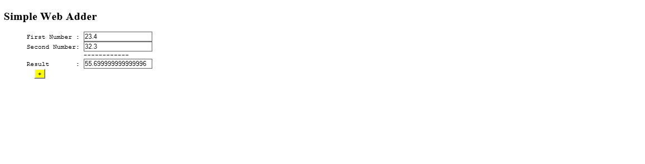

<!DOCTYPE html>

<html xmlns="http://www.w3.org/1999/xhtml">

<!--JQCalculator.html-->

<head>

<title></title>

<script src="https://ajax.googleapis.com/ajax/libs/jquery/1.12.0/jquery.min.js"></script>

<script type="text/javascript">

$(function () {

$("#btnCompute").click(doCompute);

$('#btnCompute').css({ 'background-color': 'yellow' });

$('#txtN1').keypress(handleKey1);

$('#txtN2').keypress(handleKey2);

$('#txtN1').focus();

});

function handleKey1(ev) {

var key = ev.which || ev.keyCode;

if (!(((key >= 48) && (key <= 57)) || (key == 46)))

ev.preventDefault();

if (key == 13)

$("#txtN2").focus();

}

function handleKey2(ev) {

var key = ev.which || ev.keyCode;

if (!(((key >= 48) && (key <= 57)) || (key == 46)))

ev.preventDefault();

if (key == 13)

doCompute();

}

function doCompute() {

var n1 = parseFloat($('#txtN1').val());

if (isNaN(n1)) {

alert('invalid first number');

$('#txtRes').val("");

$('#txtN1').focus();

return;

}

var n2 = parseFloat($('#txtN2').val());

if (isNaN(n2)) {

alert('invalid second number');

$('#txtRes').val("");

$('#txtN2').focus();

return;

}

var operation = $("input[name=radOperation]:checked").val().toUpperCase();

switch (operation) {

case "ADD": res = n1 + n2;

break;

case "SUB": res = n1 - n2;

break;

case "MUL": res = n1 * n2;

break;

case "DIV": res = n1 / n2;

break;

}

$('#txtRes').val(res);

}

</script>

</head>

<body>

<h2> Simple Web Calculator </h2>

<form name="f1">

<pre>

First Number : <input name="txtN1" id="txtN1" />

Second Number: <input name="txtN2" id="txtN2" />

------------

Result : <input name="txtRes" id="txtRes" />

</pre> &nbsp;&nbsp;&nbsp;&nbsp;&nbsp;&nbsp;

Add <input name="radOperation" type="radio" checked="checked" value="Add"/> &nbsp;&nbsp;&nbsp;

Sub <input name="radOperation" type="radio" value="Sub" /> &nbsp;&nbsp;&nbsp;

Mul <input name="radOperation" type="radio" value="Mul" /> &nbsp;&nbsp;&nbsp;

Div <input name="radOperation" type="radio" value="Div" /> &nbsp;&nbsp;&nbsp;

<input type="button" name="btnCompute" id="btnCompute" value="Compute" />

</form>

</body>

</html>

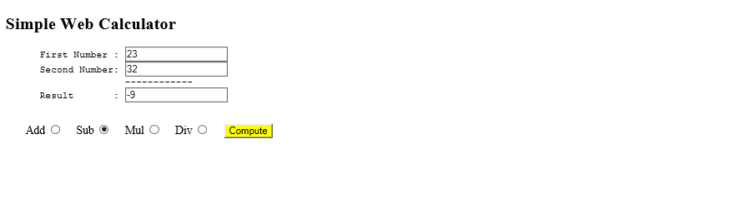

<!DOCTYPE html>

<html xmlns="http://www.w3.org/1999/xhtml">

<!-- CheckRadioJQ.htm -->

<head>

<title>Radio Buttons Processing via JQuery</title>

<script src="https://ajax.googleapis.com/ajax/libs/jquery/1.12.0/jquery.min.js"></script>

<script type="text/javascript">

$(function () {

$('#btnSubmit').click(processForm);

});

function processForm() {

var checkedChoices = "";

$("input[type=checkbox]").each(function () {

if (this.checked)

checkedChoices += $(this).val() + " ";

});

radChecked = $("input[name='rating']:checked").val();

var txtFeedback = $("#txaComments").val();

var email = $("#txtEmail").val();

alert("You selected \n" + checkedChoices + "\n" + radChecked + "\n" +

txtFeedback + "\n Your email: " +

email);

}

</script>

</head>

<body>

<h2>Site Feedback</h2>

<h4>Please provide your comments about our new site.</h4>

<form name="frmGuestBook">

<pre>

Your interest in products from our site:

Electronis : <input type="checkbox" name="chkElectronics" value="Electronicx" />

Sports : <input type="checkbox" name="chkSports" value="Sports"/>

Photography : <input type="checkbox" name="chkPhotography" value="Phtoto"/>

<br/>

E-mail Address: <input name="txtEmail" id="txtEmail" size="40" maxlength="40" value="" />

Rating:

<input type="radio" name="rating"

value="Excellent" checked="checked"> Excellent<br/>

<input type="radio" name="rating"

value="Very Good"> Very Good<br/>

<input type="radio" name="rating" value="Good"> Good<br/>

<input type="radio" name="rating" value="Fair"> Fair<br/>

<input type="radio" name="rating" value="Poor"> Poor<br/>

General Comments:

<textarea name="txaComments" id="txaComments" rows="5" cols="80"></textarea>

<input type="button" name="btnSubmit"

id="btnSubmit" value="Submit Comments" /> <input type="reset" value="Reset" />

<br/>

</pre>

</form>

</body>

</html>

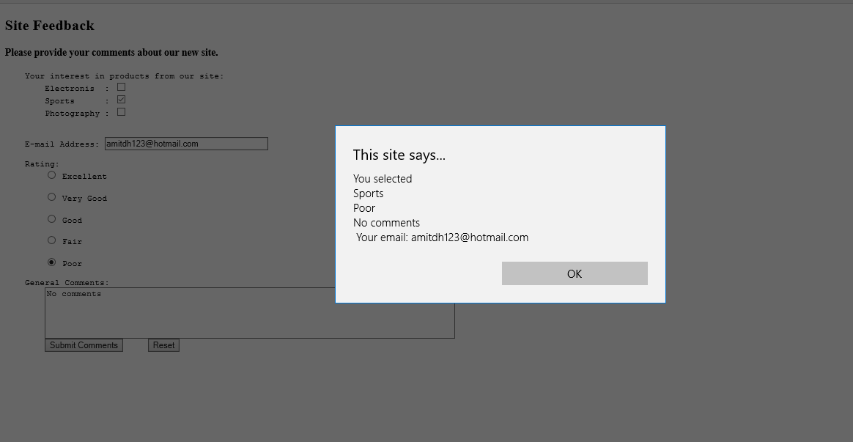

**Custom Slider Self Made:**

**HTML**

<!DOCTYPE html>

<html>

<head>

<title>Jquery Slider</title>

<link rel="stylesheet" type="text/css" href="style.css">

<script src="https://ajax.googleapis.com/ajax/libs/jquery/1.12.0/jquery.min.js"></script>

<script type="text/javascript" src="implementation.js"></script>

</head>

<body>

<center><h1> Jquery Slider Demo</h1><br>

<div class="slider">

<ul class="slidingimages">

<li class="slide"><img src="images/image1.jpeg"></li>

<li class="slide"><img src="images/image2.jpeg"></li>

<li class="slide"><img src="images/image3.jpg"></li>

<li class="slide"><img src="images/image4.jpg"></li>

<li class="slide"><img src="images/image5.jpg"></li>

</ul>

</div></center>

</body>

</html>

**CSS**

.slider{width: 720px; height: 450px;text-align: center;overflow: hidden;}

.slidingimages{width: 8000px;display: block;margin: 0px;padding: 0px;height: 400px;}

.slide{float: left;width: 720px; height: 450px;list-style-type: none;}

**Jquery:**

$(document).ready(function(){

var width = 720;

var pause = 3000;

var animationspeed = 1000;

var currentslide = 1

var $sliderdiv = $('.slider');

var $slidingUL = $sliderdiv.find('.slidingimages');

var $slider = $slidingUL.find('.slide');

setInterval(function(){

$slidingUL.animate({'margin-left':'-='+width} , animationspeed , function(){

currentslide = currentslide + 1;

if(currentslide === $slider.length){

currentslide = 1;

$slidingUL.css('margin-left',0);

}

});

} , pause);

});

